Chapter 12 Section 2
“The Catholic Reformation”
Look through the textbook and write statements describing each point below. Include as much as possible and use the 5 “w’s “as a guide.
- Effort to reform from within

- Spanish inquisition

- The “General” –Jesuits

- Ursuline Order

- Council of Trent

- Fight

- Missionaries

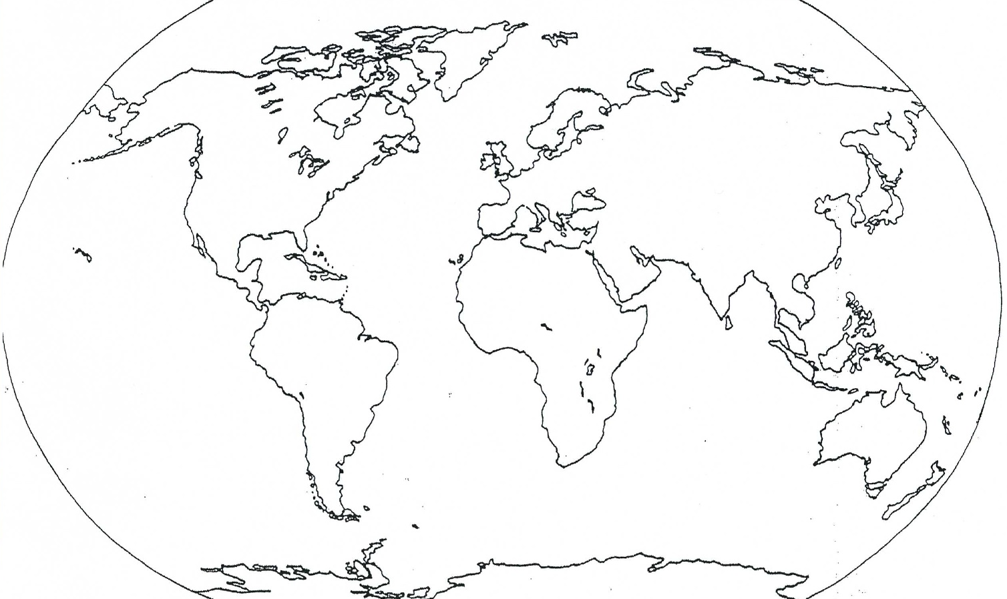

Color down below the routes the French, Portuguese and Spanish took. For a more detailed map see page 448. (don’t forget about a key and compass rose)

